Title

A. Author¹, B. Author², and C. Author^{1,2}*
¹Affiliation, full postal address including country, e-mail for the corresponding author*
²Affiliation, full postal address including country

Abstract (up to 1 page) should be prepared in English according to the rules. Please follow the predefined here fonts, style, and spacing.
Figures should be inserted into the text as one-piece objects. Figures resolution should be not less than 300 dpi, in raster format (tif, jpg, etc.). The text in figures must be readable and not intersected. Figure borders should not extend beyond the page margins. Figures may be colored. Figures created in MS Word are not accepted.
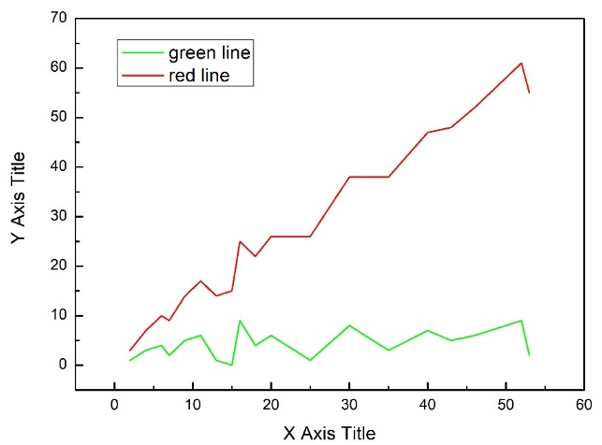
Figure caption
Tables presented in the text should be titled. Table title should be aligned in the center of the page. The title is placed above the Table. Table borders should not extend beyond the page margins.
Table title
Column 1 | Column 2
If a list of references and acknowledgment is needed, use 10-point Times New Roman font as below. Please send the abstracts to conf.apssp@yandex.by.
Acknowledgement <optional>
References <optional>
[1] A. Author [et al.] Journal Title Abbreviation Volume (Year) Pages.
[2] A. Author [et al.] Book. Publisher (Year) Pages. (for book).

